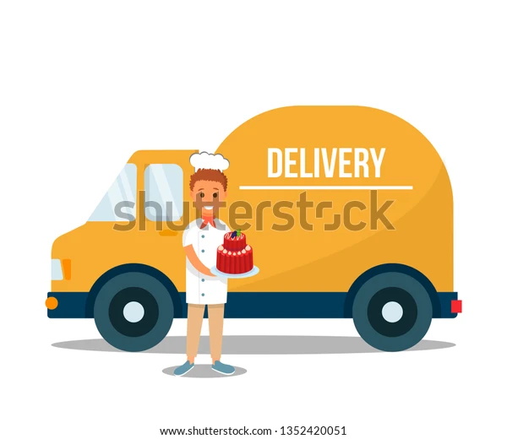

(Shutterstock, [s.a])

Ntokozo Ndlovu

Diploma in Information Technology in Network Management (DINM Group 1)

ST10474678

Prepared for: Shanty’s Bakery

Prepared by: Ntokozo’s Web Design Solutions

Date: 13 August 2025

Shanty’s Bakery

Location: 247 Main Street, Krugersdorp, South Africa

History

Shanty’s Bakery began in 1978 as a small family kitchen in the hearts of Krugersdorp. Founded by Shanty and John Duke, the bakery started with a single oven and a passion for making fresh homemade pastries and cakes for the neighbors but later in life it became a big part of the community through its customers. The bakery is known for its commitment to produce high quality ingredients and a taste that no one can forget. The bakery is having a challenge of not having a website relying on walk-in customers (Ntokozo, 2025).

Mission

Our mission is to bring joy to the community through delicious, affordable and fresh baked goods made with love and care.

Vision

To become the most loved bakery in Krugersdorp, known for quality and warm customer service.

Target Audience

Event planners, schools, and Residents.

Goals

* Enhance customer experience by creating menus and prices that customers can find easily.
* Increase sales through online orders.
* Consider Google Map integration so customers can quickly and easily get directions.

Objectives

* Increase sales by 30%.
* Increase customer satisfaction.
* Ingredients should be enriched to alter the taste, produce texture that is flakier and improve the quality of the nutrition.
* Create seasonal specials to generate excitement (Thacker, 2025).

Key Performance Indicators

* **Customer Retention Rate**: Measures the percentage of customers that often buy at the bakery.
* **Delivery Times**: Ensures that deliveries of orders are delivered on time maintaining customer satisfaction and operational efficiency.
* **Foot traffic**: Monitor the number of visitors, helping with understanding the peak hours and optimizing staff scheduling as well as service efficiency.

Strength and weaknesses

* The business sells fresh goods and ensures that prices are affordable, allowing customers to return very often.
* There is no marketing knowledge leading to walk-ins and lack of online visibility.

Our plan is to make sure that the business has a website to make things easier and be able to attract many people, allowing the business to grow (Ntokozo, 2025).

Website features

* **Home Page**: Images of products that are offered.
* **About us**: History of Shanty’s bakery, mission.
* **Menu & Product**: Customers can view prices, pictures and description of what is offered.
* **Contact Page**: Location Map, Phone numbers and email address.

Functionality

* Customers should be able to track their order, browse and place orders.
* There should be an option which allows customers to choose from delivery or in-store pickup.
* Customers can leave their reviews and ratings.

Design and User Experience

* **Color Scheme**: Yellow Palette (Clem, 2023).
* **Typography:** Accessibility: Ensure there is easy access for both customers and deliveries.

Good visibility: The bakery should be seen from the sidewalk or street.

* **Gentle slope**: Allows customers or deliver vehicles to reach the bakery easily without any obstacles on the road.

Technical Requirements

**Domain Name Requirements**

* Relevance: The name chosen should reflect the purpose of the website.
* Availability: Check whether the domain name is available using the domain registrar’s tool.

**Hosting Name Requirements**

* Website size: The amount of storage space should be considered.
* Budget: The hosting plan that is chosen should fit the budget and provide resources that are necessary (Ashwin, 2025).
* The HTML language will be used.

Timeline and Milestones

* Planning and Design- 1 week
* Development- 2 Weeks
* Testing- 4 days
* Launch- 2 days

Budget

* Development- R4500
* Hosting- R700
* Maintenance- R500
* Total: 5700

You won’t regret working with us, we offer low prices and make sure that our work is reliable and is high quality.

# References

Clem, A., 2023. *What is a Color Scheme? Defination, Types, and Examples.* [Online]   
Available at: <https://www.shutterstock.com/blog/color-scheme-definitions-types-examples>  
[Accessed 17 August 2025].

Ntokozo, N., 2025. Website Proposal for Shanty's Bakery [unpublished proposal]. Johannesburg.

S, A., 2025. *Web Hosting vs Domain Name: A Comprehensive Guide.* [Online]   
Available at: <https://hostafrica.co.za/blog/domains/domain-basics/domain-vs-hosting/>  
[Accessed 16 August 2025].

Shutterstock, [s.a]. *1+ thousand delivery truck cakes.* [Online]   
Available at: >https://www.shutterstock.com/image-vector/delivery-man-holding-double-decker-fruit-1352420051>  
[Accessed 16 August 2025].

Thacker, M., 2025. *How to Price Baked Goods (+3 Tips for Managing an In-Store Bakery).* [Online]   
Available at: <https://www.itretail.com/blog/price-baked-goods>  
[Accessed 17 August 2025].